

**Kingdom of Saudi Arabia**

**Ministry of Education**

**King Faisal University**

**College of Computer Sciences & Information Technology**

**Arduino-based Home Automation System Using Bluetooth**

**Controlling** **home lights.**

*A* ***project report*** *submitted for the course of*

*CN 312 – Mobile and Wireless Networks*

**By Group Members**

|  |  |
| --- | --- |
| **Name** | **ID** |
| Hussein Ali Aljaziri | 221429366 |
| Abdullah Almuhana | 220034088 |

**Supervised by: Abdullah Al buali**

**May, 2024**

**Abstract**

Arduino-based Home Automation System Using Bluetooth is a project that allows the user to take control over multiple devices at home, like controlling lights, by using Bluetooth or Wi-Fi from their smart phone. The system aims to provide users with convenient and efficient control over their lighting setup through the integration of Arduino microcontrollers and Bluetooth modules. At the core of the system lies an Arduino microcontroller acting as the central control unit, which communicates with the user's mobile via Bluetooth connectivity. Through a dedicated mobile application, users can remotely interact with the system to turn lights on and off and adjust brightness levels. By harnessing the power of Arduino and Bluetooth technology, this project offers an accessible and cost-effective solution for enhancing home lighting control. The versatility of Arduino allows for future expansion and integration with other home automation functionalities. Through the implementation of this Arduino-based home automation system, users can experience the benefits of enhanced convenience and energy efficiency while also gaining insights into the practical application of embedded systems and wireless communication protocols in real-world scenarios.

**Table of Contents**

Abstract 2

Introduction 4

Detailed System Description 4

Network Design 5

Wireless and Mobile Concepts 6

Conclusion: 7

Reference 8

Project Marking Guide 9

**Introduction:**

In an era where technology seamlessly intertwines with daily life, the concept of home automation stands at the forefront of innovation. With the advent of Arduino microcontrollers and wireless communication protocols like Bluetooth, the dream of a smart, interconnected home is now within reach of DIY enthusiasts and tech aficionados alike. This project aims to leverage the versatility of Arduino and the convenience of Bluetooth technology to create a robust and customizable home automation system. Like controlling the house lights. By harnessing the power of Arduino boards and Bluetooth modules, users can control their home lighting remotely from their mobile devices. This project encapsulates the essence of modern living, where comfort, efficiency, and sustainability converge seamlessly.

**Detailed System Description:**

In this project we used:

* Arduino Mega 2560
* 4 Channel Relay Module 5V
* HC-05 Bluetooth Module
* Bulb
* Natural Electricity from Home
* Arduino IDE

First, we connected the HC-05 Bluetooth Module to the Arduino like this.

* HC-05 Bluetooth Module >> Arduino
* VCC >> 3.3V
* GND >> GND
* TXD >> RX0
* RXD >> TX0

Second, we connected the 4 Channel Relay Module 5V to the Arduino as well like this.

* 4 Channel Relay Module 5V >> Arduino
* GND >> GND
* IN1 >> PWM 2
* IN2 >> PWM 3
* IN3 >> PWM 4
* IN4 >> PWM 5
* VCC >> 5V

Finally, we connected the Bulb to the 4 Channel Relay Module 5V.

We connected the pin of the bulb to Normally open and commonly open.

**Network Design**:

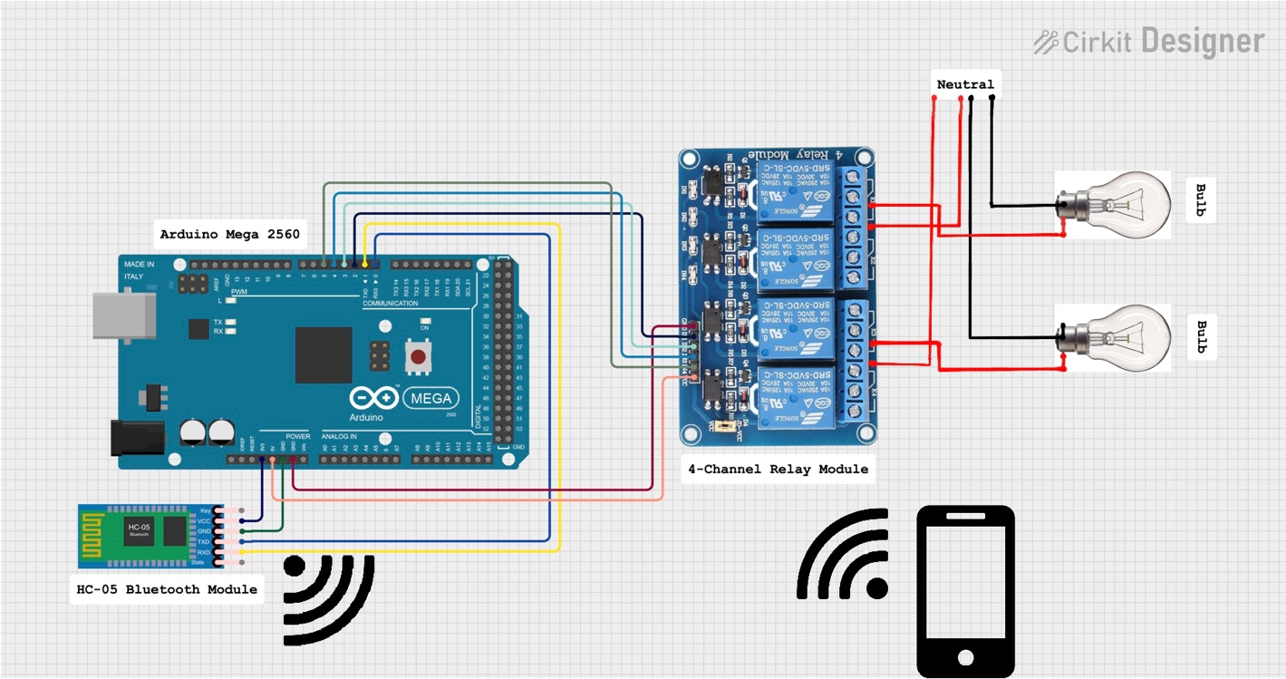

Figure 1

**Wireless and Mobile Concepts:**

1. **Bluetooth Technology:** 
   * Bluetooth modules such as the HC-05 facilitate wireless communication between the Arduino microcontroller and mobile devices.
   * Bluetooth's low energy consumption and ubiquity make it an ideal choice for home automation systems, ensuring efficient data transmission without excessive power consumption.
2. **Arduino Integration:**

* Arduino serves as the central control unit, interfacing with Bluetooth modules to manage lighting systems.
* Arduino's versatility and ease of integration allow for seamless communication with Bluetooth modules and effortless control over lighting fixtures.

1. **Mobile Device Interface:**

* Mobile applications provide a user-friendly interface for controlling home lighting remotely.
* Through the mobile app, users can send commands to the Arduino via Bluetooth, enabling functions such as turning lights on/off, adjusting brightness.

1. **Wireless Connectivity:**

* The HC-05 Bluetooth Module establishes a wireless connection between the Arduino and mobile devices, eliminating the need for physical wires and enabling flexible placement of control interfaces.
* Wireless connectivity enhances user convenience and mobility, allowing for control of home lighting from any location within Bluetooth range.

# **Conclusion:**

In conclusion, the Arduino-based Home Automation System employing Bluetooth technology for home lighting control stands as a groundbreaking achievement in smart home innovation. By seamlessly integrating Arduino microcontrollers, Bluetooth modules, and mobile applications, this project proves the feasibility and efficacy of wirelessly managing lighting systems within homes. Utilizing Arduino as the central control hub provides a flexible and user-friendly foundation for implementing automation and remote-control features. Through Bluetooth connectivity, users can effortlessly engage with the system via their smartphones, enjoying the convenience of lighting control from anywhere within Bluetooth range. Furthermore, the system's scalability ensures adaptability to evolving user preferences and technological advancements. Whether incorporating additional sensors for environmental monitoring or integrating voice control capabilities, the Arduino-based solution can readily accommodate diverse household requirements. Overall, this project underscores the transformative potential of Arduino-based solutions in reshaping home automation, delivering heightened control, energy efficiency, and convenience to users. As smart home technologies progress, the synergy between Arduino and Bluetooth connectivity remains a promising avenue for fostering intelligent and interconnected living environments.

**Reference:**

1. <https://ielectrony.com/%d9%86%d8%b8%d8%a7%d9%85-%d8%a3%d8%aa%d9%85%d8%aa%d8%a9-%d8%a7%d9%84%d9%85%d9%86%d8%b2%d9%84-%d8%a8%d8%a7%d8%b3%d8%aa%d8%ae%d8%af%d8%a7%d9%85-%d8%a7%d9%84%d8%a8%d9%84%d9%88%d8%aa%d9%88%d8%ab/>
2. <https://www.youtube.com/watch?v=Ou2zK1aZXMA&list=PLeCOeSiMn5UEjRnZ8drL5zRXonMUkRWCU&index=2>
3. <https://www.researchgate.net/publication/363468004_Bluetooth_Based_Home_Automation_Using_Arduino>
4. Application for drawing: Cirkit Designer

**Project Marking Guide**

**Project Title:** Arduino-based Home Automation System Using Bluetooth

**Team Members:**

|  |  |  |  |
| --- | --- | --- | --- |
|  | **Assignment Component** | **Max. Marks** | **Marks Obtained** |
| **Report** | Format (Table of Contents, References, formatting, font, etc....) | 10 |  |
| English language (grammar and spelling) | 10 |  |
| Introduction | 15 |  |
| References | 10 |  |
| Contents  Design, and Discussions | 55 |  |
| **Report mark** | 100 * 0.15 |  |
| **Presentation** | Questions and answers | 15 |  |
| Design & Usability | 25 |  |
| Testing (Various Input Conditions) | 15 |  |
| Presentation skills | 15 |  |
| Understanding / Explanation of the Design | 30 |  |
| **Presentation Mark** | 100 * 0.05 |  |
|  | **Total Mark** | 20 |  |
|  | Plagiarism report more than 30% to 35%  Plagiarism report more than 36% to 40%  Plagiarism report more than 41% to 45%  Plagiarism report more than 45% | - 10  - 30  - 60  - 100 |  |
|  | USING AI | -100 |  |